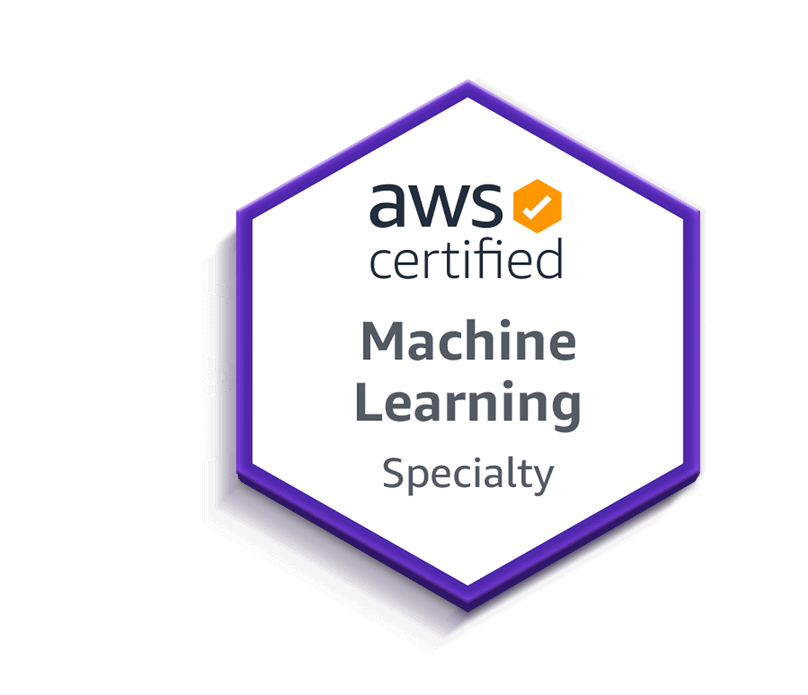
Cloud/DevOps Engineer

Sai Gudavalli
Phone: + 1 (951) 359-9295‬‬‬‬‬‬‬‬‬‬‬‬‬‬‬
Email: gudavallisai98@gmail.com
Experienced DevOps Engineer with a strong background in building and releasing applications
ETL | Data bricks | Data Visualizations | Batch procession pipelines | Python | PowerShell | Azure DevOps | AWS Services | Amazon CloudWatch | CI/CD | GIT | Jenkins | Docker | Kubernetes | Terraform.
__________________________________________________________________________________________

PROFESSIONAL SUMMARY

- 5 + years of cumulative technical IT experience at all stages of the Software Development Life Cycle including software system design, development, testing, and deployment expertise. Designed, implemented, and managed highly scalable and fault-tolerant AWS cloud infrastructure utilizing services such as EC2, S3, RDS, IAM, Lambda, and CloudFormation.
- Developed automated CI/CD pipelines using AWS CodePipeline and Jenkins, reducing deployment time by 30%.
- Implemented Infrastructure as Code (IaC) using CloudFormation and Terraform, ensuring consistent provisioning of AWS resources and reducing manual errors.
- Optimized AWS costs by analyzing and implementing cost-effective solutions, saving 25% on monthly infrastructure expenses.
- Conducted regular security assessments and implemented best practices to secure AWS environments, including IAM policies, security groups, and VPC configurations.
- Deployed Azure resources and services including Virtual Machines, Storage Accounts, Azure SQL Database, and Azure Functions to support enterprise applications.
- Developed data integration pipelines using Azure Data Factory for efficient data movement and transformation across on-premises and cloud environments.
- Designed and implemented Azure Synapse Analytics solutions for data warehousing and big data analytics, improving data processing efficiency by 40%.
- Utilized Azure DevOps for CI/CD pipelines to automate build, test, and deployment processes, enhancing overall development agility.
- Designed and implemented Prometheus-based monitoring for critical infrastructure, creating custom metrics and alerting rules to detect anomalies and performance bottlenecks, reducing incident response times.
- Developed and maintained real-time Grafana dashboards, visualizing application performance metrics and system health to provide actionable insights for engineering and operations teams, enhancing monitoring coverage and improving resource allocation.
- Established Splunk logging pipelines to aggregate and analyze log data from multiple applications and services, enabling efficient root cause analysis and troubleshooting.
- Integrated Prometheus with Grafana for automated anomaly detection, and configured Splunk alerts to provide early warnings on critical issues, improving the team’s proactive resolution capabilities and minimizing system downtime.
- Proficient in DevOps methodologies, specializing in CI/CD pipeline design and implementation.
- Extensive expertise in Amazon Web Services (AWS) and Microsoft Azure, including EC2, S3, IAM, VPC, Azure Synapse, ADF, Azure Devops and cloud formation templates.
- Hands-on experience with Terraform for provisioning and managing infrastructure components like RDS, VPCs, and load balancers.
- Proficient in containerization technologies like Docker and Kubernetes, enabling efficient application deployment and scaling.
- Managed source code using GIT, ensuring version control and enabling collaborative development.
- Monitored application performance using tools such as Amazon CloudWatch, App Dynamics, and SPLUNK, enabling proactive issue resolution.
- Designed and maintained Infrastructure as Code (IAC) using Terraform, ensuring consistent and scalable environments.
- Collaborated with development teams to optimize application performance and troubleshoot issues within Kubernetes clusters.
- Utilized Ansible playbooks for configuration management and application deployment, improving efficiency and consistency.
- Proficient in writing Docker files and managing Docker registries, streamlining application packaging and distribution.
- Played a key role in migrating applications from traditional server environments to containerized solutions.
- Demonstrated expertise in virtualization technologies, including VMware, enhancing resource utilization and flexibility.
- Led the setup and maintenance of Kubernetes clusters, enabling seamless container orchestration and management.
- Participated in the design and execution of disaster recovery and business continuity plans for critical applications.
- Leveraged automation scripts to streamline infrastructure provisioning and configuration tasks.

Micron Technology, Denver, Colorado April 2024 - May 2025
Sr. Aws/ Azure DevOps Engineer
Responsibilities:
- Designed and implemented fully automated CI/CD pipelines using Jenkins, Git, Docker, and Kubernetes for deploying microservices to AWS (EKS) and Azure (AKS).
- Deployed and managed highly scalable and secure infrastructure on AWS using Terraform, CloudFormation, and Ansible.
- Automated provisioning of resources and cloud infrastructure (EC2, S3, IAM, RDS, Lambda) with Infrastructure as Code (IaC) tools, improving deployment time by 30%.
- Worked with AWS Lambda to automate routine tasks and enable serverless architecture for specific projects.
- Integrated Splunk with AWS environments for real-time monitoring and log management, improving incident response times by 25%.
- Maintained and optimized Kubernetes clusters (AKS and EKS) for high availability and auto-scaling across multiple environments.
- Collaborated with development teams to ensure best practices in CI/CD pipelines, including automated testing, security scanning, and monitoring.
- Leveraged Python and Bash scripts to automate deployment and configuration tasks, improving operational efficiency.
- Implemented SRE practices to improve system reliability and reduce downtime for cloud-based applications hosted on AWS and Azure.
- Developed CI/CD pipelines with Jenkins for automating the build, test, and release processes, ensuring rapid and consistent delivery.
- Managed containerized applications using Docker and orchestrated deployments with Kubernetes, ensuring consistent performance and scalability.
- Configured AWS IAM roles, policies, and security groups for secure cloud infrastructure management.
- Conducted root cause analysis for system incidents, identifying performance bottlenecks and improving system uptime by 15%.
- Implemented CloudFormation templates and Terraform scripts for deploying and managing AWS resources, ensuring infrastructure consistency.

Environment: -Terraform, Aws, Ansible, Git, Python, Jenkins, Cloud Formation, CyberArk, PowerShell, .Net, GitHub Actions, PowerShell, Git (Version Control, Agile Methodology, Automated Testing Frameworks, Continuous Integration (CI), Continuous Deployment (CD).

Fanniemae, Reston, Virginia Nov 2023- March 2024
Sr. Aws/DevOps Application Migration Engineer
Responsibilities:
- Led the successful migration of CyberArk application (v 12.2) from on-premises to AWS cloud environment for a large financial company, ensuring seamless integration and minimal downtime.
- Designing and implementing pipelines, and automating CyberArk deployment processes using Ansible and PowerShell, resulting in increased efficiency and scalability.
- Spearheaded the development of custom plugins using Python and .NET to enhance CyberArk functionality within the AWS environment, facilitating smoother operations and improved security measures.
- Independently managed project tasks, collaborating effectively with cross-functional teams to execute migration plan within set timelines, demonstrating strong autonomy and project management skills in a remote work environment.
- Implemented infrastructure as code principles by utilizing Terraform and CloudFormation templates to provision and configure AWS resources, ensuring consistent deployment and scalability across environments, with a focus on Windows-based systems.
- Orchestrated server provisioning and pipeline setup, leveraging AWS services and tools to automate CyberArk deployment processes using Ansible and PowerShell, significantly reducing manual intervention and enhancing operational efficiency.
- Provided ongoing support for the migrated application, troubleshooting issues, and implementing continuous improvements to optimize performance and reliability.
- Applied strong programming skills in Python, PowerShell, and .NET to develop automation scripts, streamline processes, and enhance system functionality, contributing to the overall success of the migration project and enhance system functionality, contributing to project success and client satisfaction.
- Led the planning and execution of migrating messaging infrastructure from RabbitMQ to Amazon SQS, ensuring minimal downtime and smooth transition for existing systems.
- Updated configuration settings in codebase and deployment configurations to integrate with Amazon SQS, including endpoint URLs, authentication credentials, and queue attributes.
- Led the planning and execution of migrating messaging infrastructure from RabbitMQ to Amazon SQS, ensuring minimal downtime and smooth transition for existing systems.
- Utilized Terraform and CloudFormation templates to manage AWS infrastructure as code, promoting consistency, scalability, and version control across environments, with a focus on Windows-based systems.
- Collaborated effectively with the project team to independently execute tasks and meet project milestones, demonstrating strong leadership and autonomy in a remote work setting.

Environment: -Terraform, Aws, Ansible, Git, Python, Jenkins, C, Cloud Formation, CyberArk, PowerShell, .Net, GitHub Actions.

Tata Consultancy Services (TCS), Bangalore, India Apr 2020 to Aug 2021
Aws/Synapse DevOps Engineer
Responsibilities
- Led the development of end-to-end data pipelines on Aws Synapse, enhancing data ingestion, transformation, and loading processes for optimal performance and reliability.
- Utilized Azure DevOps to establish robust CI/CD pipelines, automating deployments and ensuring seamless integration across diverse environments.
- Collaborated across cross-functional teams to design and implement alerting and notification systems using Logic Apps, improving real-time monitoring and issue resolution.
- Leveraged Power BI to create interactive dashboards, empowering stakeholders to make data-driven decisions and gain deeper insights into business operations.
- Formulated comprehensive governance policies, ensuring consistent and compliant practices across Aws Landing Zones.
- Managed resource dependencies effectively within Terraform configurations.
- Implemented security best practices within Terraform code, ensuring a secure infrastructure environment.
- Familiarity with the broader Terraform ecosystem, including providers, modules, and community contributions.
- Developed scalable architecture patterns within Landing Zones to accommodate business growth and dynamic workloads.
- Complex AWS infrastructure using CloudFormation templates (YAML/JSON) to automate provisioning of VPCs, EC2, RDS, IAM, S3, Lambda, and CloudWatch resources.
- Developed modular, reusable, and parameterized CloudFormation stacks using nested stacks and macros to enforce infrastructure-as-code (IaC) best practices across multiple environments.
- Integrated advanced security measures, including identity and access management, encryption, and monitoring, to enhance data protection.
- Designed intricate networking configurations, such as virtual networks, subnets, and peering, creating well-connected Landing Zones.
- Employed automation tools to streamline Landing Zone deployment and management, effectively reducing manual efforts.
- Created custom resources using AWS Lambda-backed functions in CloudFormation for advanced automation not supported natively, such as dynamic AMI selection and DNS validation.
- Orchestrated deployment workflows using PowerShell and Python scripts, minimizing manual intervention and accelerating software updates.
- Spearheaded the transition from manual deployments to automated CI/CD pipelines, resulting in a 50% reduction in deployment errors and increased efficiency.

Environment: Aws Synapse, Aws DevOps, Logic Apps, Power BI, PowerShell, Python, Aws Dashboards, Docker, Kubernetes, Git, Jira, Aws Active Directory, Aws SQL Database, Aws Data Factory, Jenkins, CI/CD Pipelines, Unit Testing, Integration Testing, Agile Methodology.

Tata Consultancy Services (TCS), Bangalore, India Apr 2019 to march 2020
Aws/Azure DevOps Engineer
Responsibilities:
- Designed, configured, and managed intricate CI/CD pipelines in Azure DevOps for multiple applications, driving a remarkable 96% improvement in deployment efficiency.
- Collaborated with development teams to define branching and merging strategies, promoting effective code collaboration and version control.
- Automated cloud infrastructure provisioning with Terraform and AWS CloudFormation, adhering to Infrastructure as Code (IaC) best practices.
- Configured and maintained AWS services, including EC2, S3, RDS, and IAM, to support cloud-hosted applications, improving resource efficiency by 25%.
- Collaborated with security teams to implement role-based access control (RBAC) and enforce compliance using AWS IAM, Azure AD, and Key Vault.
- Automated serverless workflows with AWS Lambda, Step Functions, and Azure Functions, reducing operational overhead by 35%.
- Optimized cloud cost management and budgeting using AWS Cost Explorer and Azure Cost Management, reducing cloud expenditure by 10%.
- Successfully integrated data from diverse sources like SAP and Service Now into Azure Data Factory pipelines, enabling smooth data transformation and loading processes.
- Utilized CloudFormation drift detection to identify configuration mismatches between deployed resources and template definitions, ensuring infrastructure consistency.
- Integrated CloudFormation with Secrets Manager and Parameter Store (SSM) to securely manage environment-specific secrets and parameters in automated deployments.
- Developed PowerShell scripts for task automation, resulting in 100% time savings and minimizing errors.
- Implemented Azure Monitor to establish comprehensive monitoring and alerting solutions, enhancing application performance and addressing potential issues proactively.
- Collaborated cross-functionally to architect and build Azure Logic Apps for automated workflows, contributing to operational efficiency and reduced manual intervention.
- Leveraged Azure Databricks for advanced data processing and analysis, enabling deeper insights for informed business decision-making.
- Led knowledge-sharing sessions on Azure DevOps best practices, fostering continuous learning and skill enhancement within the team.
- Actively participated in Agile ceremonies, promoting transparency, collaboration, and continuous improvement.
- Implemented security measures within Azure DevOps pipelines, ensuring adherence to industry standards and safeguarding sensitive data.

Environment: Aws/Azure DevOps, ADF, Azure Monitor, Logic Apps, Azure Databricks, SAP, ServiceNow, PowerShell, Git (Version Control), CI/CD Pipelines, Agile Methodology, Automated Testing Frameworks, Disaster Recovery Strategies, Continuous Integration (CI), Continuous Deployment (CD), Automated Workflows, Monitoring.

Collabridge PVT LTD, Chennai, India March 2018 to Feb 2019
Build and Release Engineer
Responsibilities:
- Proficient in deploying, managing, and optimizing applications on AWS and Azure, utilizing services such as Amazon EC2, S3, Lambda, Azure Virtual Machines, and Azure App Services.
- Designed and implemented end-to-end CI/CD pipelines using Jenkins, Git, and Bitbucket, enabling rapid and reliable application deployments. Reduced deployment time by 40% through efficient automation.
- Led Kubernetes adoption, containerizing applications for scalability and resilience. Utilized Docker for containerization and managed Kubernetes clusters for efficient orchestration.
- Developed IaC using tools like Terraform, enabling consistent infrastructure provisioning. Achieved infrastructure consistency across development, testing, and production environments.
- Implemented comprehensive monitoring using tools like Prometheus and Grafana, ensuring real-time visibility into application performance. Set up centralized logging with ELK stack for efficient troubleshooting.
- Implemented security best practices by configuring network security groups, firewalls, and role-based access controls (RBAC) to safeguard cloud infrastructure. Conducted regular security audits and assessments.
- Designed and maintained highly available systems with multi-region deployments and auto-scaling. Reduced downtime by 30% by implementing active-active failover strategies.
- Implemented cost-saving strategies by utilizing reserved instances, rightsizing resources, and implementing serverless architectures, resulting in a 20% reduction in operational costs.

PROJECTS

AI-Powered E-commerce Website Project | TensorFlow, AWS, Hugging Face, Open AI GPT, Docker, Kubernetes, CI/CD Pipelines, Django, Python
- Designed and implemented an end-to-end e-commerce website with AI technologies for personalized shopping experiences, including product recommendations, pricing.
- Developed a dynamic pricing model using regression algorithms to adjust product prices in real-time based on demand, competition, and user behavior.
- Integrated the model with the e-commerce platform using REST APIs, resulting in a 15% increase in revenue.
- Created an AI chatbot using NLP tools to handle customer queries, provide product information, and assist in the checkout process, reducing customer support response time by 40%.

CERTIFICATIONS

- AWS Certified Machine Learning Engineer - Associate
• Skilled in designing and developing scalable, ML solutions on AWS applications.

- Certified Kubernetes Administrator
•Configured and maintained Kubernetes clusters including troubleshooting, and core networking concepts, node management, pod scheduling, and persistent storage using kubectl and YAML configurations.
- Certified Entry-Level Python Programmer
• Gained hands-on experience in fundamental Python concepts including data types, control flow, and functions with Python syntax, debugging, and writing basic scripts.

EDUCATION:-
Masters in computer and information sciences
Westcliff University, USA 2021 Aug – 2023 Apr

Bachelor’s in computer science,
J.K.C College, Inida 2016 Apr – 2019 Mar

